Encapsulation:
Encapsulation combines data members and member functions, which operate on those data members, into a single unit. Encapsulation describes the ability of an object to hide its data and methods from the rest of the world and is one of the fundamental principles of object-oriented programming. In Java, a class encapsulates the fields, which hold the state of an object, and the methods, which define the object's actions. Encapsulation enables you to write reusable programs. It also enables you to restrict access only to those features of an object that are declared public. All other fields and methods are private and can be used for internal object processing.
Setter & Getter:
For each instance variable, a getter method returns its value while a setter method sets or updates its value. Given this, getters and setters are also known as accessors and mutators, respectively.
By convention, getters start with the word "get" and setters with the word "set", followed by a variable name. In both cases the first letter of the variable's name is capitalized:
public class Vehicle {
private String color;
// Getter
public String getColor() {
return color;
}
// Setter
public void setColor(String c) {
this.color = c;
}
}
The getter method returns the value of the attribute. The setter method takes a parameter and assigns it to the attribute.

We use getters and setters:
- for reusability
- to perform validation in later stages of programming
Getter and setter methods are public interfaces to access private class members.

Encapsulation
The encapsulation is to make fields private and methods public.
- Getter Methods: We can get access to private variables.
- Setter Methods: We can modify private fields.
Even though the getter and setter methods do not add new functionality, we can change our mind come back later to make that method
- Better;
- Safer; and
- Faster.
Anywhere a value can be used, a method that returns that value can be added. Instead of:
int x = 1000 - 500
Use
int x = 1000 - class_name.getValue();
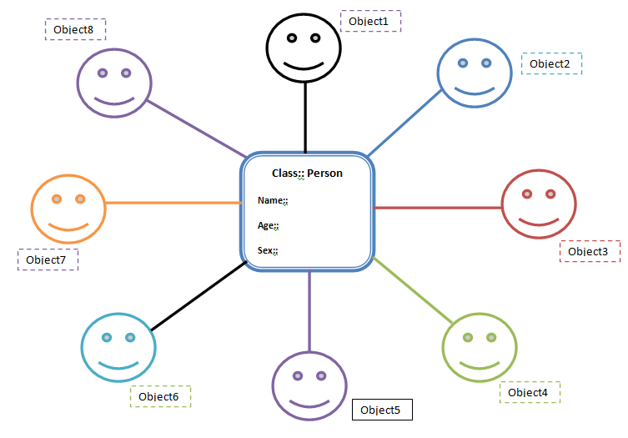
Gender::

Suppose we need to store the details of this Person. This Person has the fields name, age and gender. Doing this involves creating methods for name, age, and gender. Now if we need to create another person, it becomes necessary to create the methods for name, age, gender all over again.
Instead of doing this, we can create a bean class (Person) with getter and setter methods. So tomorrow we can just create objects of this Bean class (Person class) whenever we need to add a new person (see the figure). Thus we are reusing the fields and methods of bean class, which is much better.

